SIMATS ENGINEERING
ASSESSMENT TOOL 1

COURSE NAME: Database Management Systems COURSE CODE: CSA05

COURSE OUTCOME COVERED

CO2: Apply the relational model, relational algebra, SQL query structures, and views to solve database querying and data manipulation problems. (BL3, BL6)

Activity Tool : Analytical Problem Solving (High) Assessment Tool Weightage: 40%

QUESTIONS
Q.N o | Question | Bloom's Level
1 | Given a set of relations and sample data, write SQL queries to retrieve specific information using joins and subqueries, and explain the logic used. Bloom’s Level: BL3 – Apply | BL4 – Analyze
2 | Using relational algebra, formulate expressions to solve complex queries such as retrieving records that satisfy multiple conditions across relations. Bloom’s Level: BL4 – Analyse | BL5 – Evaluate
3 | Given a real-world scenario (e.g., banking or student system), design a relational schema and construct appropriate SQL queries for data retrieval and updates.  Bloom’s Level: BL6 – Create | BL6 – Create
4 | Analyse a given SQL query with nested subqueries and predict its output, explaining each step of execution. Bloom’s Level: BL4 – Analyze | BL6 – Create
5 | Compare different SQL approaches (joins vs subqueries) for solving the same problem and evaluate their efficiency.  Bloom’s Level: BL5 – Evaluate | BL4 – Analyze
6 | Design and implement views for a database system to provide restricted data access, and justify their use for security and abstraction. Bloom’s Level: BL6 – Create | BL5 – Evaluate
7 | Given a database schema, write relational algebra expressions and convert them into equivalent SQL queries, analyzing differences in representation. Bloom’s Level: BL4 – Analyze | BL4 – Analyze
8 | Optimize a set of inefficient SQL queries by restructuring them using joins, indexing concepts, or views, and evaluate performance improvements. Bloom’s Level: BL5 – Evaluate | BL5 – Evaluate
9 | Develop a complex SQL query involving grouping, aggregation, and nested queries to solve a real-world problem.  Bloom’s Level: BL6 – Create | BL6 – Create
10 | Given multiple relations, analyze the query requirements and decide whether to use views, joins, or subqueries, justifying your choice with reasoning. Bloom’s Level: BL5 – Evaluate | BL5 – Evaluate

Code of Conduct:

(Name GUNAVATHI.A(192511374)/ Reg No) certify that this
submission is my original work and that I have adhered to the guidelines specified for this assessment. I understand that any violation of academic integrity rules will result in disciplinary action.
Signature of the student:

QUESTION-1:
Given a set of relations and sample data, write SQL queries to retrieve specific information using joins and subqueries, and explain the logic used.
Bloom’s Level: BL3 – Apply

ANSWER:

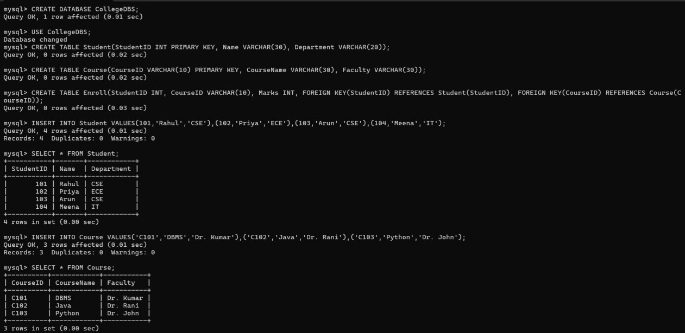

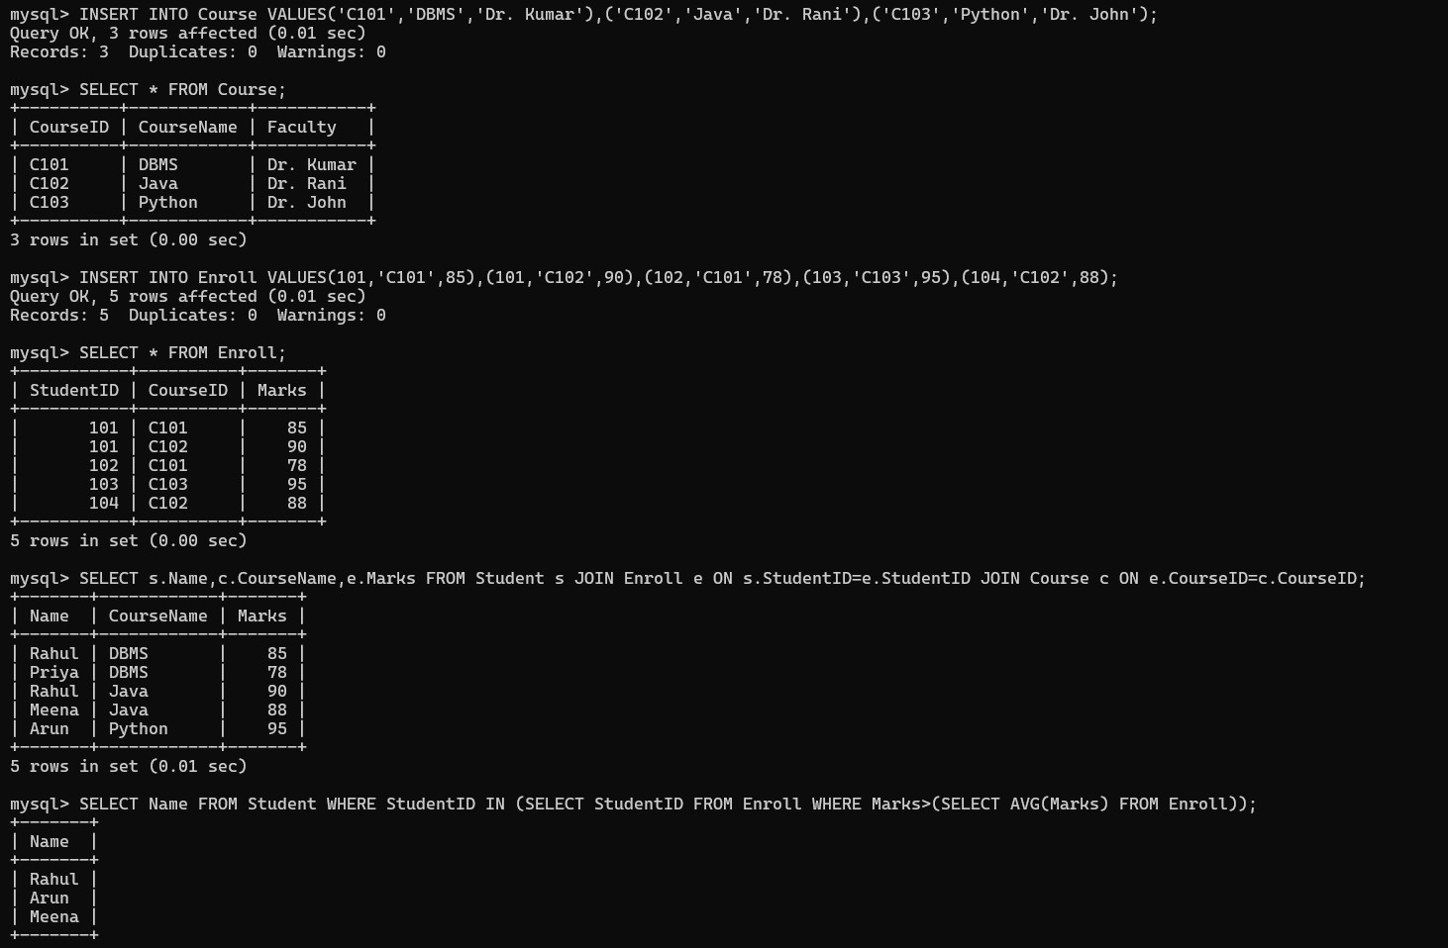

QUESTION: 2
Using relational algebra, formulate expressions to solve complex queries such as retrieving records that satisfy multiple conditions across relations.
Bloom’s Level: BL4 – Analyse
ANSWER:
RELATIONAL ALGEBRA:
R1 ← Student ⋈ Student.StudentID=Enroll.StudentID Enroll
R2 ← R1 ⋈ Enroll.CourseID=Course.CourseID Course
R3 ← σ Department='CSE' ∧ Marks>80 ∧ CourseName='DBMS' (R2)
Answer ← π Name, CourseName, Marks (R3)

In one line:
πName,CourseName,Marks(σDepartment='CSE'∧ Marks>80 ∧ CourseName='DBMS'(Student ⋈ Enroll ⋈ Course))

QUESTION: 3
Given a real-world scenario (e.g., banking or student system), design a relational schema and construct appropriate SQL queries for data retrieval and updates. Bloom’s Level: BL6 – Create
ANSWER:
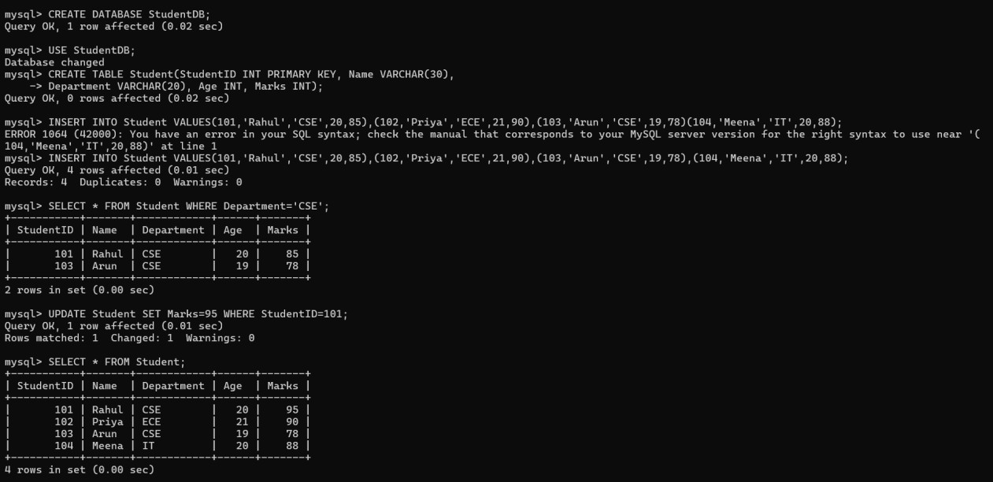

QUESTION:4
Analyse a given SQL query with nested subqueries and predict its output, explaining each step of execution.
Bloom’s Level: BL4 – Analyze OUTPUT:
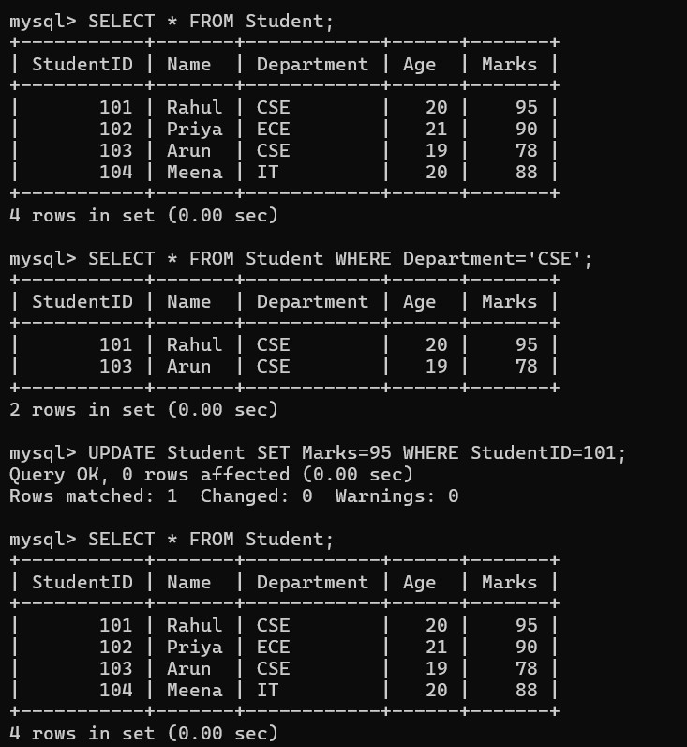

QUESTION: 5
Compare different SQL approaches (joins vs subqueries) for solving the same problem and evaluate their efficiency. Bloom’s Level: BL5 – Evaluate
OUTPUT:
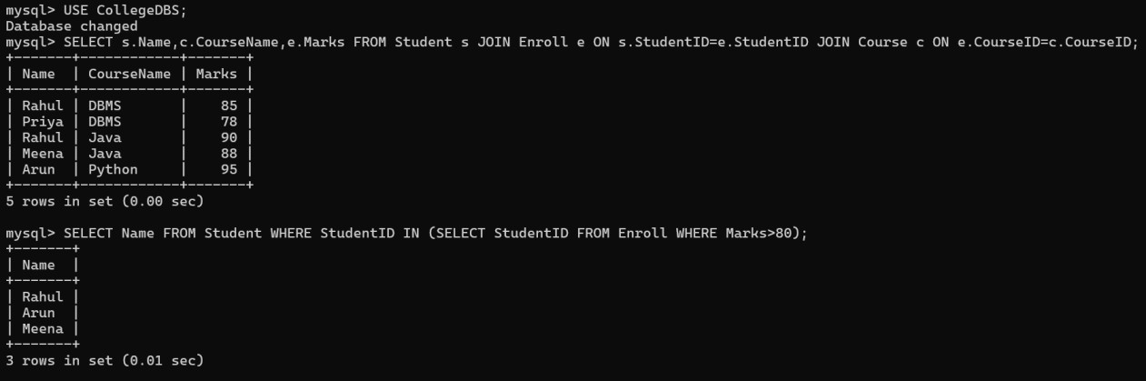

QUESTION: 6
Design and implement views for a database system to provide restricted data access, and justify their use for security and abstraction.
Bloom’s Level: BL6 – Create
ANSWER:
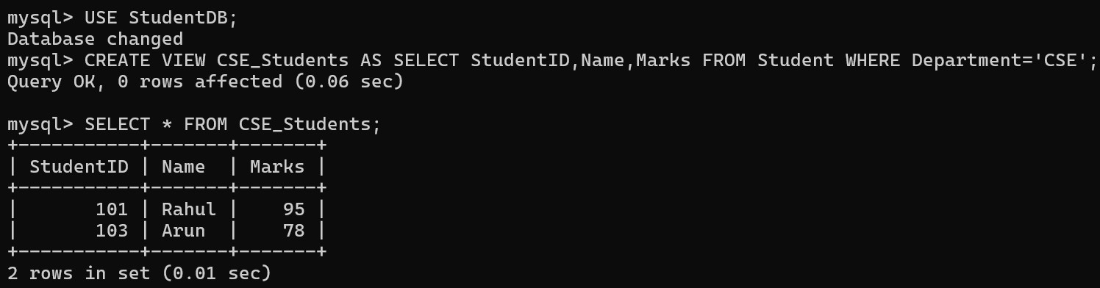
JUSTIFICATION:
- A View is a virtual table based on one or more tables.
- It provides restricted access by showing only the required columns and rows.
- It improves security by hiding unnecessary data and provides abstraction by simplifying complex queries.

QUESTION:7
Given a database schema, write relational algebra expressions and convert them into equivalent SQL queries, analyzing differences in representation.
Bloom’s Level: BL4 – Analyze
ANSWER:
RELATIONAL ALGEBRA:
πName,CourseName,Marks(σDepartment='CSE'∧ Marks>80 ∧
CourseName='DBMS'(Student ⋈ Enroll ⋈ Course))
SQL QUERY:
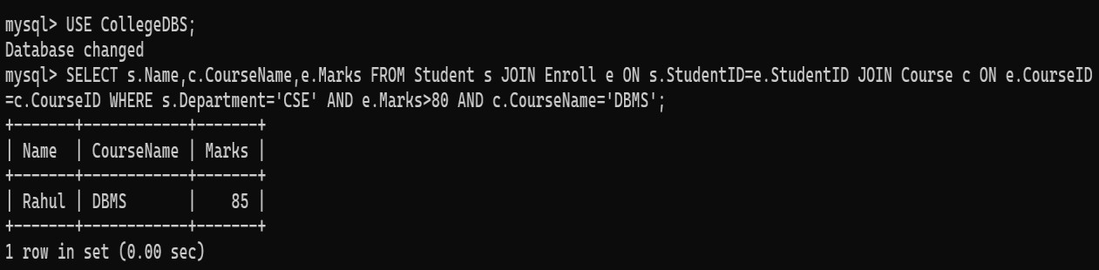

QUESTION: 8
Optimize a set of inefficient SQL queries by restructuring them using joins, indexing concepts, or views, and evaluate performance improvements.
Bloom’s Level: BL5 – Evaluate
ANSWER:
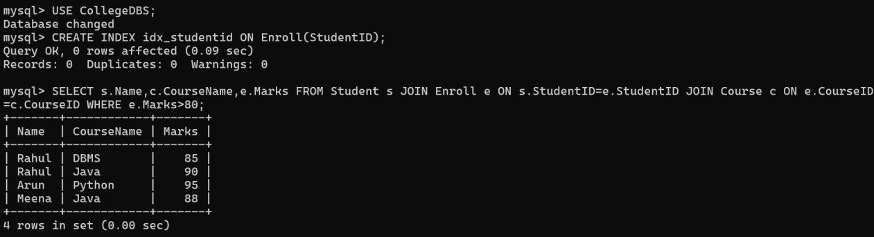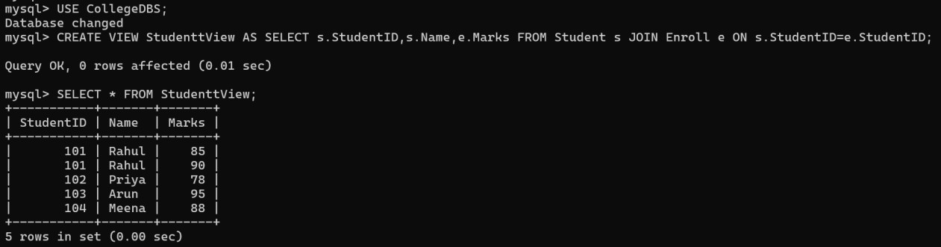
QUESTION: 9
Develop a complex SQL query involving grouping, aggregation, and nested queries to solve a real-world problem.
Bloom’s Level: BL6 – Create
ANSWER:
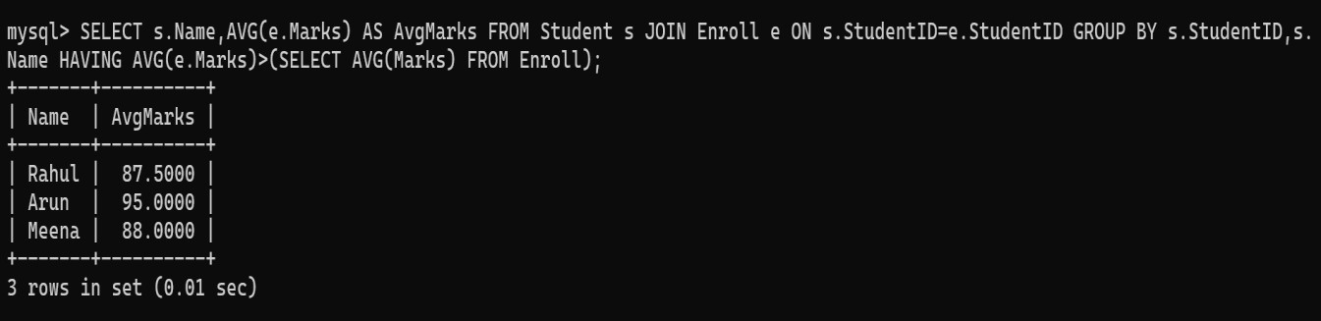

QUESTION: 10
Given multiple relations, analyze the query requirements and decide whether to use views, joins, or subqueries, justifying your choice with reasoning.
Bloom’s Level: BL5 – Evaluate
ANSWER:
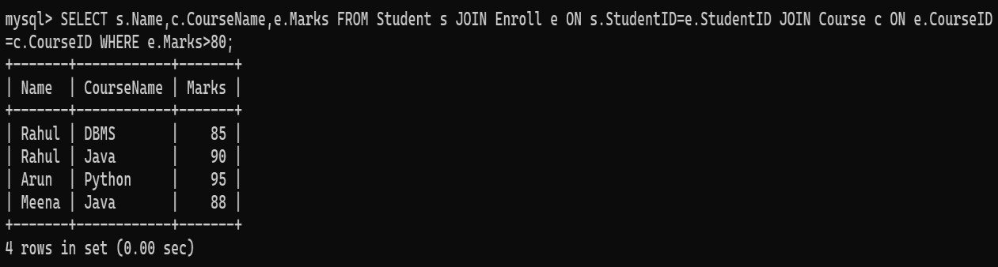

JUSTIFICATION:
- JOIN is the best choice because the required data is stored in multiple related tables (Student, Enroll, and Course).
- It retrieves all the required information in a single query.
- It is generally more efficient than subqueries for this type of retrieval.
- Views are useful for simplifying repeated queries and restricting data access, but a JOIN is more appropriate here for fetching related data from multiple tables.
RUBRICS FOR CALCULATION:

Criteria | Level 4 (Exemplary) | Level 3 (Proficient) | Level 2 (Developing) | Level 1  (Beginning  )
Problem  Understandin g | Clearly interprets problem,  identifies all parameters and  requirements accurately | Understand s problem  with minor gaps | Partial understandin  g; misses key elements | Misinterpret s or unable  to  understand problem
Method  Selection | Selects most appropriate  method/formul a with strong justification | Selects correct  method with minor errors | Inappropriate or partially correct method | Unable to select method
Solution Process | Logical, systematic  steps with correct  approach throughout | Mostly correct  steps with minor mistakes | Disorganized steps;  multiple errors | No clear process
Accuracy of  Calculation | All calculations accurate; | Minor calculation errors | Frequent errors;  incorrect final answer | No valid calculations
 | correct final answer
Interpretation of Results | Clearly interprets  results with units and  engineering relevance | Basic interpretatio  n with minor omissions | Limited or unclear interpretation | No  interpretatio n

